**Abstract**

**Introduction**

The development of uranium-based fuel was growing rapidly during the 1950’s and 60’s, leading to the development of UO2 and Mixed oxide fuel (MOX) fuels due to their stability under irradiation and high melting point, which are important safety features. The need for a sustainable energy source to maintain the current and increasing demands for energy in the world accelerated the process of developing Generation IV (GEN-IV) reactors ‎[2]. Recent developments in material properties of uranium alloys revived the interest in metallic fuel for Gen IV reactors. The high density of fissile material in uranium (U) in its metallic form, and its relatively higher thermal conductivity compared to oxides and mixed oxides fuels, makes it an attractive option as a main fuel in advanced nuclear reactors ‎[1]. Despite these beneficial properties, the issues of the lower melting point of uranium alloys and its phase instability under irradiation and at high temperature ranges needs to be addressed. Alloying uranium with zirconium (Zr) or molybdenum (Mo) is usually performed to stabilize high temperature uranium phases to lower temperatures relevant to nuclear reactors, improving irradiation performance while also increasing the melting point. It is therefore important to study such alloys for nuclear fuel applications.

Uranium metal has three stable solid phases: α (face-centered Orthorhombic) up to 935 K, β (body-centered tetragonal) between (935K and 1045 K) and γ (body-centered cubic) up to melting point (1407 K).‎[4]‎[5] The vast majority of experimental and computational work was performed on the α phase of uranium ‎[6]‎[7]‎[8] because of the mechanical instability of the γ phase at room temperature. Performing high temperature experiments on nuclear materials poses significant challenges that have ultimately led to limited experimental investigation of the γ phase. This emphasizes the importance of computational work in investigating these alloys at temperatures applicable to nuclear reactors. Zirconium is alloyed with U in order to increase the melting point (the melting temperature of Zr is 2125 K) and to stabilize the high temperature γ phase. Zirconium has a hexagonal close-packed structure up to 1140K, above which the phase transfors to bcc up to the melting point.‎[9] The identical high temperature crystal structure, in addition to broad solubility, leads to a high temperature bcc U-Zr phase that is a random solid substitutional alloy. Additionally, Zr is compatible with the steel cladding and inhibits migration of cladding constituents into the fuel that might reduce its melting point‎[10].

The U-10Zr (10 weight percent) alloy has been typically used as a metal fuel in fast reactors. It was the driver fuel in the Experimental Breeder Reactor (EBR-II). EBR-II was an experimental Sodium Fast Reactor (SFR) where many experiments were performed to investigate the fuel performance and safety features of such type of reactors. The historical utilization of the ratio in the fresh fuel implemented in such types of reactors led to the research of the fuel properties to focus on obtaining information at this ratio. Indeed, most of the experimental database used to validate the fuel performance codes are based on experimental U-10Zr.‎[11] This means that the models do not consider the constituent redistribution during irradiation in the reactor, which leads to variation of the zirconium concentrations, producing regions with enriched zirconium, and others with depleted zirconium.‎[12] Therefore, it is important to study the fuel properties at different concentrations of zirconium, whether it is low concentrations down to U-2Zr or zirconium enriched regions with concentrations as high as U-15Zr, because these concentrations exist in real fuel, and can have significantly different properties than U-10Zr.

Beeler et al. has performed ab initio molecular dynamics (AIMD) work on γ-U. The linear thermal expansion they obtained fits well with the lattice parameter calculated by Basak et al.‎[13]‎[14] Their results however deviated from the data by Touloukian.‎[15] The density of uranium was determined at 1060 K from the lattice parameter measured by Lawson et al.‎[16] to be 17.92 g/cm3. Experimental work was performed on β-Zr to estimate its lattice parameters. Heiming et al. used neutron diffraction methods to estimate the lattice parameter for Zr for temperatures between 1173 K to 1823 K.‎[17]. Petukhov determined the thermal expansion of high temperature zirconium for temperature ranges between 1200 K to 1830 k‎[18] while Paradis and Rhim determined the volume expansion coefficient for β-Zr at 2128 K and for liquid zirconium to be 2.35x10^-5 K-1 and 4.6x10-5 K-1 respectively.‎[19] The density of zirconium was determined for β-Zr to be 6.47 g/cm3 at 1250 K.‎[19] The thermal expansion of U-Zr systems were determined by Touloukian and by Basak.‎[14]‎[15] Basak predicted lower linear thermal expansion with zirconium content than touloukian. He also predicted an increase in the thermal expansion with zirconium content which opposes the idea that zirconium has a lower thermal expansion than uranium. The heat capacity of γ-U was determined by Konings and Benes.‎[20] Zirconium heat capacity was determined as a function of temperature.‎[21] Both metals’ heat capacities showed temperature dependency. The heat capacity of γ-(U,Zr) were determined at 1000 K for 6, and 9 wt.%Zr to be 33.8, and 34.3 J/mol.K respectively.[ref 73 metal fuel]. Moore et al. performed Molecular Dynamics (MD) simulations to determine the heat capacity of U-Zr.[moore paper] The heat of formation was determined by Landa et al. using Density Function Theory (DFT) at 0 K.[Landa paper] The surface energy was determined by Beeler et al. used MD methods to determine the surface energy.

Add in a DFT->AIMD short paragraph.

The goal of this work is to study the thermophysical properties of γ U-Zr alloys at various concentrations between 3 to 20 wt.%Zr using AIMD. The work started by investigating the equilibrium volumes at various temperature and compositions and obtaining the corresponding equilibrium lattice parameters. The linear thermal expansion, heat capacities, and formation enthalpies were computed as a function of temperature and composition. The work is completed by investigating surfaces energies of the (100) and (110) orientations.

**Computational details**

AIMD was used to performed quantum mechanical molecular dynamics calculations at high temperature. AIMD has been successfully used to investigate systems such as liquid phase diffusion in Al-Si system,8 and finite temperature phonon dispersion curves in bcc Z and bcc Li.9 Soderlind et al. utilized self-consistent ab initio lattice dynamics SCAILD to study the high temperature stabilization of the γ-U phase by calculating phonon modes at 1100 K .10

The Vienna ab initio Simulation Package (VASP) was utilized for all the performed calculations.11-12 The Projector augmented wave (PAW) method was utilized within the DFT framework.13 The calculations were performed using the Perdew-Burke-Ernzerhof (PBE) Generalized gradient Approximation (GGA) density functional implementation for the description of the exchange-correlations.14 For uranium, a PAW pseudopotential with fourteen valence electrons and a core represented by [Xe,5d,4f] was utilized. For Zirconium, the pseudopotential contained twelve valence electrons while the core was defined by [Ar,4d]. A Monkhorst-Pack15 1x1x1 k-point mesh was used for Brillouin zone sampling.[ref from ben’s paper] U is assumed to be non-magnetic, in accordance with experiments, hence, the calculations are non-spin polarized. The energy cutoff was taken to be 300 eV, which is approximately 50 eV higher than the maximum suggested energy cutoff from the pseudopotentials, with the electronic self-consistent loop convergence criterion taken to be 10-4. The timestep is taken to be 2.0 fs and the simulations are performed for 2500 timesteps, for a total simulation time of 5 ps. When surfaces are investigated for temperatures between 1300 K and 1400 K, extended simulations for up to 28 ps were performed to stabilize the system’s energy before performing extra runs with a simulation time of 5 ps to obtain more accurate systems’ energies. The Hubbard U parameter is not utilized in this work, as it has been shown that it is not necessary for the accurate description of metallic U [cite some DFT papers on pure U from Beeler, Wirth, Mei, et al.].

The simulations were performed on a supercell consisting of 128 atoms (4x4x4 bcc unit cell) with periodic boundary conditions. The pressure as a function of volume for each temperature and composition was obtained and the second-order Birch-Murnaghan Equation of State (EOS) was fitted to these data and the bulk modulus was evaluated. The optimized equilibrium unit cell volume is obtained for the structure that reduces the total pressure to zero. At this optimized structure, calculations are performed to obtain the thermal expansion, bulk modulus, heat capacity, formation enthalpy, and free energy of mixing as a function of temperature and composition.

The bulk modulus is defined by equation 1:

|  |  |
| --- | --- |
| $$B_{0}= -V_{0}(\frac{∂P}{∂V})$$ | 1 |

where $B_{0}$ is the bulk modulus, $V_{0}$ is the equilibrium total volume of the cell, P and are the pressure and volume respectively. The Birch-Murnaghan EOS is evaluated by inserting the values obtained from equation 1 into equation 2

|  |  |
| --- | --- |
| $$P\left(V\right)=\frac{3}{2}B_{0} \left[{\left(\frac{V_{0}}{V}\right)}^{7/3}- {\left(\frac{V_{0}}{V}\right)}^{5/3} \right]$$ | 2 |

The equilibrium lattice parameter is calculated from equation 3

|  |  |
| --- | --- |
| $$a\left(T\right)=\sqrt[3]{V_{0}/64}$$ | 3 |

where *a* is the equilibrium lattice parameter at temperature T. The equilibrium total volume is divided by 64 to obtain the volume of the unit cell.

The coefficient of thermal expansion was calculated using equation 4:

|  |  |
| --- | --- |
| $α=\frac{{\left(\frac{V_{2}}{V_{1}}\right)}^{\frac{1}{3}}-1}{T_{2}-T_{1}}$ | 4 |

Where V and T are the system’s volume and temperature respectively at state 1 and 2. The heat capacity is determined using equation 5

|  |  |
| --- | --- |
| $$C_{p}=\frac{H_{2}-H_{1}}{T_{2}-T_{1}}$$ | 5 |

where H and T are the system’s enthalpy and temperature respectively at state 1 and 2. When the system is simulated at equilibrium conditions with zero pressure, then its enthalpy would be equal to the internal energy which is the sum of the potential and kinetic energies.

The formation energy per atom is determined by the equation 6

|  |  |
| --- | --- |
| $$E_{f}=\frac{E\left(UZr\right)-E\left(U\right)N(U)-E(Zr)N(Zr)}{N}$$ | 6 |

where $E\left(UZr\right)$ is total energy of the UZr system, $E\left(U\right)$ and $E(Zr)$ are the energy per atom of U and Zr respectively, $N(U)$ and are the number of atoms of U and Zr, respectively, in the system of interest, and N is the total number of atoms in the system.

The surface energy is calculated by creating a U-Zr system with a section of vacuum in the supercell oriented in a specific fashion. The energy of the system with a vacuum is obtained from the simulations results and the surface energy is calculated using equation 6

|  |  |
| --- | --- |
| $$E_{surf}=\frac{E^{*}-E }{2A}×N$$ | 7 |

where $E^{*}$ and $E$ are the energy of a system with a surface and a perfect UZr system respectively, N is the number of atoms in the system, A is the surface area, and there exist two surfaces in the system due to periodic boundaries.

**Results**

***Structural parameters***

The pressure as a function of volume was calculated between 900 K and 1400 K for metallic γ-U and β-Zr and their alloys up to 20% Zr concentrations. The results are interpolated to obtain the equilibrium system volume, which is defined as the volume resulting in zero pressure. With the equilibrium volume, the bulk modulus is computed using equation 1, along with the equilibrium lattice parameter from equation *2*. The results are plotted in Fig. 1 for metallic uranium. For each temperature, the parametrized second-order Birch-Murnaghan equation of state (EOS) is plotted.

The equilibrium lattice parameter is summarized in *Table 1* and plotted in *Fig. 2*. For uranium, the lattice parameter is generally underpredicted when compared to the experimental value at 1060 K obtained by Lawson [reference 40 Beeler paper], which was 3.493 Å, however, this is in accordance with previous computational results. The lattice parameter of Zr showed good agreement with the correlation based on the experimental data by Heiming et al.[Heiming paper]. It is expected that the underprediction of the U lattice parameters would lead to a certain degree of underprediction of the lattice parameters of the U-Zr alloys. The bulk modulus data are summarized Table 2. For uranium metal, the data are close to what was calculated by Yoo[ref 1 beeler paper] utilizing a temperature independent equation of state (113 GPa). The general trend of the predicted values shows a degree of softening of the bulk modulus as the temperature increases, which is to be expected.

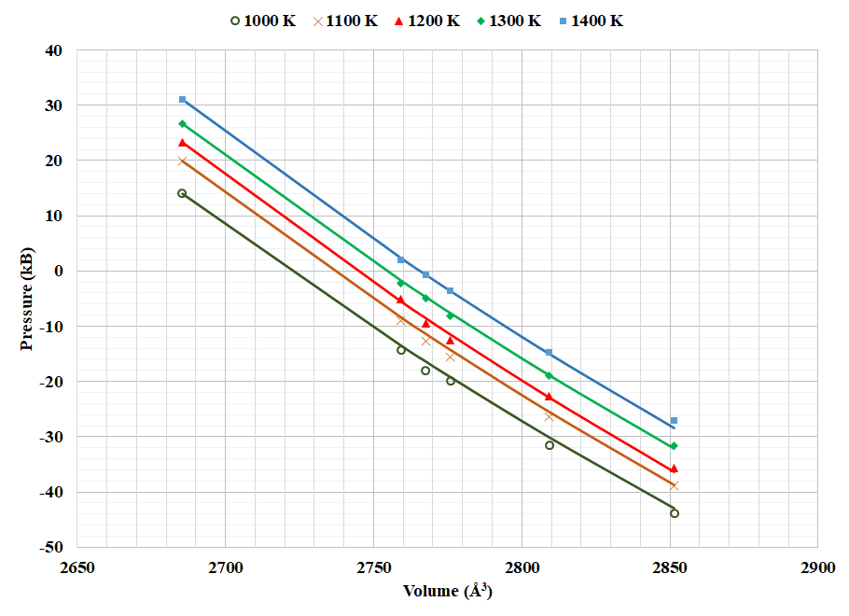

Fig. 1. The pressure as a function of system volume for γ-U between 1000 K and 1400 K. The AIMD data are represented by the discrete lines and the parameterized second-order Birch-Murnaghan EOS is represented by the solid lines.

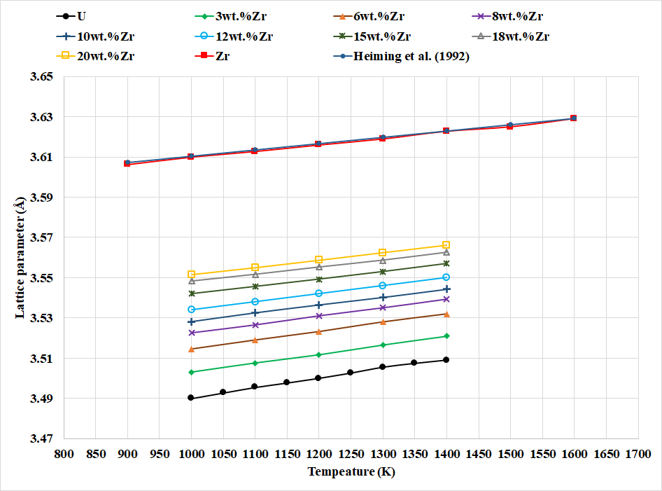

Fig. 2. The equilibrium lattice parameter as a function of temperature for a number of U-Zr compositions.

Table 1 Summary of equilibrium lattice parameters in Å between 1000 K and 1400 K and for zirconium content between 0 wt.% and 20 wt.%. For 100 wt.% percent Zr, the data are obtained between 1000 and 1600 K.

|  |  |  |  |  |  |  |  |  |  |  |
| --- | --- | --- | --- | --- | --- | --- | --- | --- | --- | --- |
|  | **Zirconium concentration (wt.%)** | | | | | | | | | |
| **Temperature (K)** | **0** | **3** | **6** | **8** | **10** | **12** | **15** | **18** | **20** | **100** |
| **1000** | 3.490 | 3.503 | 3.515 | 3.523 | 3.528 | 3.534 | 3.542 | 3.548 | 3.552 | 3.610 |
| **1100** | 3.495 | 3.508 | 3.519 | 3.527 | 3.533 | 3.538 | 3.546 | 3.552 | 3.555 | 3.613 |
| **1200** | 3.500 | 3.512 | 3.523 | 3.531 | 3.537 | 3.542 | 3.549 | 3.555 | 3.559 | 3.616 |
| **1300** | 3.505 | 3.517 | 3.528 | 3.535 | 3.540 | 3.546 | 3.553 | 3.559 | 3.563 | 3.619 |
| **1400** | 3.510 | 3.521 | 3.532 | 3.540 | 3.544 | 3.550 | 3.557 | 3.563 | 3.566 | 3.623 |
| **1500** |  |  |  |  |  |  |  |  |  | 3.625 |
| **1600** |  |  |  |  |  |  |  |  |  | 3.629 |

Table 2 Summary of bulk modulus data in GPa between 1000 K and 1400 K and for zirconium content between 0 wt.% and 20 wt.%. For 100 wt.% percent Zr, the data are obtained between 1000 and 1600 K.

|  |  |  |  |  |  |  |  |  |
| --- | --- | --- | --- | --- | --- | --- | --- | --- |
|  | **Zirconium concentration (wt.%)** | | | | | | | |
| **Temperature (K)** | **0** | **6** | **10** | **12** | **15** | **18** | **20** | **100** |
| **1000** | 106.98 | 106.0 | 96.0 | 108.7 | 80.4 | 104.7 | 74.0 | 92.00 |
| **1100** | 110.23 | 105.0 | 98.0 | 108.8 | 91.5 | 101.8 | 90.5 | 87.5 |
| **1200** | 112.00 | 104.0 | 100.0 | 109.2 | 95.0 | 96.0 | 99.2 | 84.5 |
| **1300** | 110.45 | 102.0 | 102.0 | 110.0 | 90.5 | 87.3 | 99.6 | 81.0 |
| **1400** | 111.73 | 101.0 | 104.5 | 111.2 | 78.4 | 75.7 | 92.0 | 79.5 |
| **1500** |  |  |  |  |  |  |  | 78.0 |
| **1600** |  |  |  |  |  |  |  | 78.0 |

The Linear Thermal Expansion (LTE) is defined as

|  |  |
| --- | --- |
| $LTE=$ $\frac{L-L_{0}}{L_{0}}*100$ | 8 |

where $L_{0}$ is the lattice parameter at a reference temperature which was chosen to 1100 K. Fig. 3 depicts the obtained lattice parameters in this work as dotted lines. These values were compared to the data by Basak and Touloukian after referencing them to a system at 1100 K to make the comparison meaningful. As noticed in Fig. 3, the LTE is underpredicted relative to both datasets. Touloukian predicted a decrease of LTE with Zr content which is the expected trend because the thermal expansion of Zr is lower than the thermal expansion of U. , predicting an increase in LTE with Zr content. Until more data are generated this range of LTE is generally acceptable.

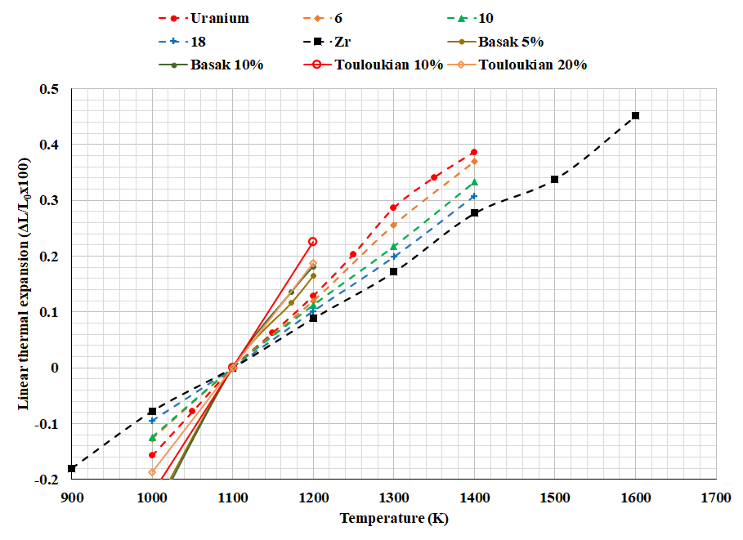

Fig. 3. The equilibrium lattice parameter as a function of temperature.

Computing an average LTE coefficient over this temperature range produced a value of 15.5x10-6 K-1, which as we have noted is less than the value reported by [reference 14 in metal fuel handbook] of 22.5x10-6 K-1. For Zr, the average LTE coefficient was calculated to be 9x10-6 K-1, which is slightly higher than the value predicted by Petukhov [reference 243 metal fuel handbook] (insert value of Petukhov) and much lower than the value predicted by Paradis and Rhim [ref 242 metal fuel handbook] (23.5x10-6 K-1). Fig. 4 depicts the LTE coefficient as a function of zirconium content.

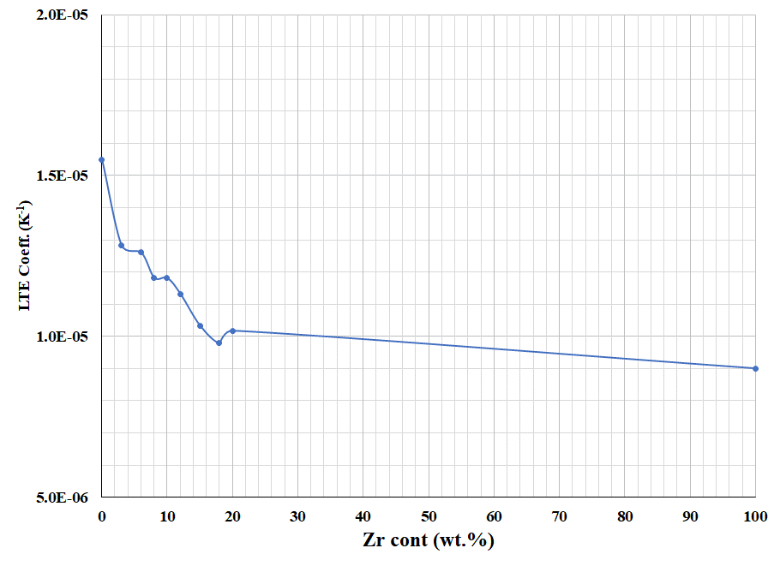

Fig. 4. LTE Coefficient as a function of zirconium content.

***Specific heat***

For metals such as U and Zr, the electronic effects on heat capacity should be taken into consideration along with the lattice effects and anharmonic effects. The electronic heat capacity results from excitation of ground state electrons to a conduction state and is therefore proportional to the Density of States (DOS) at the Fermi energy. Therefore, the electronic heat capacity can be estimated using the equation 9

|  |  |
| --- | --- |
| $$C_{el}=\frac{π^{2}}{3}k_{B}^{2}*D\left(ϵ_{f}\right)=γ_{e}T$$ | 9 |

where $ϵ_{f}$ is the fermi energy, $D\left(ϵ_{f}\right)$ is the DOS at the fermi energy, $K_{B}$ is Boltzmann constant and $γ_{e}$ is the electronic heat capacity coefficient. The DOS have been previously determined for the U-Zr system by, and a correlation for $γ_{e}$ for the U-Zr system was developed:

|  |  |
| --- | --- |
|  |  |

The electronic heat capacity from Eq. 9 is added to the lattice heat capacity from Eq. 5 to obtain the total heat capacity.

was estimated experimentally for α-U to have an average value of 10.12 mJ/mol.K2 and for β-Zr to be 2.77 mJ/mol.K2. However using equation 3 at high temperature phases gave a lower value for γ-U of 7.62 mJ/mol.K2 but similar result was obtained for β-Zr. Moore et al. performed the same calculations for U-Zr. In alloys, $γ_{e}$ showed non-linear dependence on the zirconium content and the results were fitted on a third-degree polynomial in equation 10 which is plotted in Fig. 5

|  |  |
| --- | --- |
| $$γ_{e}=7.304*Zr^{3} + 11.853*Zr^{2}+ -0.231*Zr+7.634$$ |  |

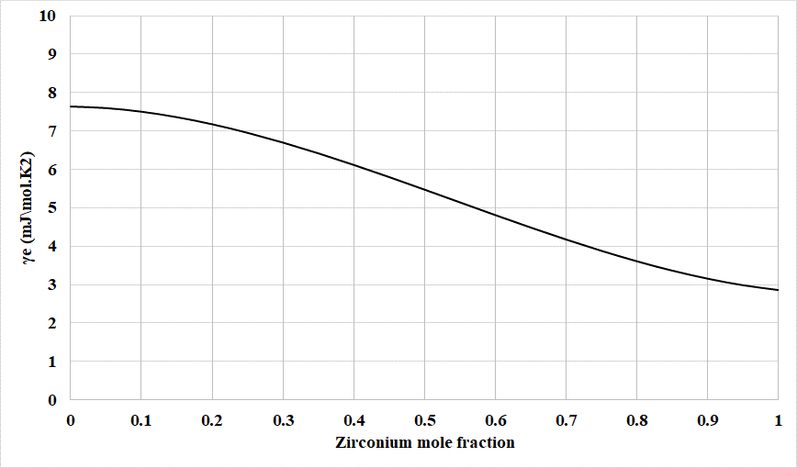

Fig. 5. The electronic heat capacity coefficient as a function of zirconium content.

Fig. 6 summarizes the calculated heat capacity in this work. Mention that these results are based on averaging of two atomic configuration It can be noticed that there is a decrease of the molar heat capacity with increasing Zr mole fraction. This is expected since the uranium heat capacity is larger than the heat capacity for zirconium. Interestingly, the trend of heat capacity with increasing temperature is

There the some discrepancies such as the almost constant behavior of the Molar heat capacity at 1400 K which is actually due to the opposite behavior obtained from the two configuration simulated which led to a constant heat capacity when averaged. Up to about 20 at.% the heat capacity of the UZr at 1000 K seems to be relatively higher than there peer values at higher temperature. The heat capacity is expected to slightly increase with temperature. This would suggest the need to run the simulations using a few more atomic configurations to reduce the variance in the produced energy values. However, the data generated in this work for 1100 K varies within 1-2 J/mol.K from the data generated by [Moore et al.] which shows a good fit with experimental data.

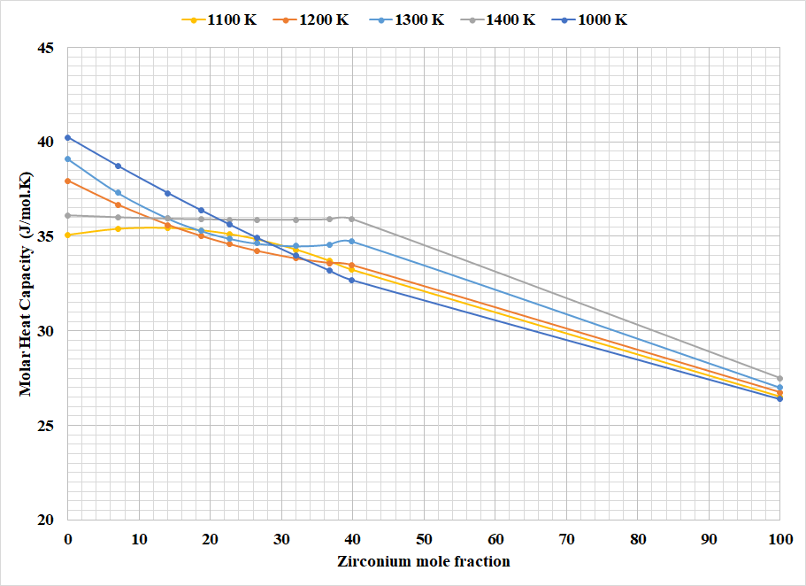

Fig. 6. The molar heat capacity as a function of the zirconium content in U-Zr.

***Energy of formation***

Fig. 7 summarizes the AIMD results of the formation energy obtained in this work for γ(U-Zr) in comparison to the results at 0 K performed by Landa et al.[land UZr paper] The figure shows a decrease of the heat of formation with the temperature which is expected and the figure also shows the magnitude of the energy difference between calculations at 0 K using DFT and AIMD calculations at temperatures above 1000 K. The deviation from Vegard’s law seems valid here and confirms the results of Landa[], but simulations at higher concentrations are needed to confirm the full results.

***Surface energy***

The surface energy was calculated using equation 7 for two surface orientations: one surface on the (100) plane and the other on the (110) plane. For these two different orientations the dimensions of the supercell will vary and the number of simulated atoms as well. For the (100) direction, then unit cell contains 2 atoms per cell. The size of the supercell is 4x4x6 cells where 4x4x4 cells contain the bulk material consisting of 128 atoms of both U and Zr, and 4x4x2 contains the void. For the (110) direction simulation the unit cell contains 4 atoms per cell. The size of the super cell is 4x3x5 where the U-Zr is contained in 4x3x3 and consists of 144 atoms and the void is in 4x3x2. The system is simulated for temperature range between 1000 k and 1400 k. The size of the void was chosen to ensure that convergence of the surface energy to a stable level. The surface energy was calculated based on running calculations for two atomic configurations.

The surface energy for the (100) surface is illustrated in Fig. 8 as a function of composition at different temperatures. The surface energy decreases with the zirconium content and increases with temperature. At higher zirconium content, the surface energy dependence on the temperature decreases. The surface energy ranges from 1.5 to 1.8 J/m2 across all temperatures and compositions analyzed. It can be observed that the surface energy at 1400 K is significantly higher than the other illustrated values. This can be explained by the fact that this temperature is much closer to the melting point, which can make the system less stable and lead to additional surface roughening. As the zirconium content increases, the melting temperature also increases, leading to a more stable system and a less dramatic increase in the surface energy at 1400 K.

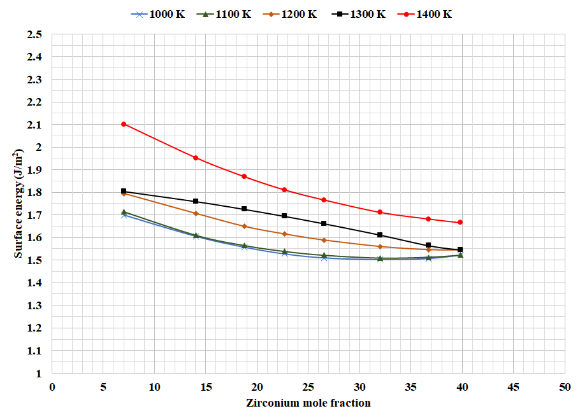

Fig. 8. Surface energy as a function of zirconium content between 1000 K and 1400 K for a surface with orientation (100).

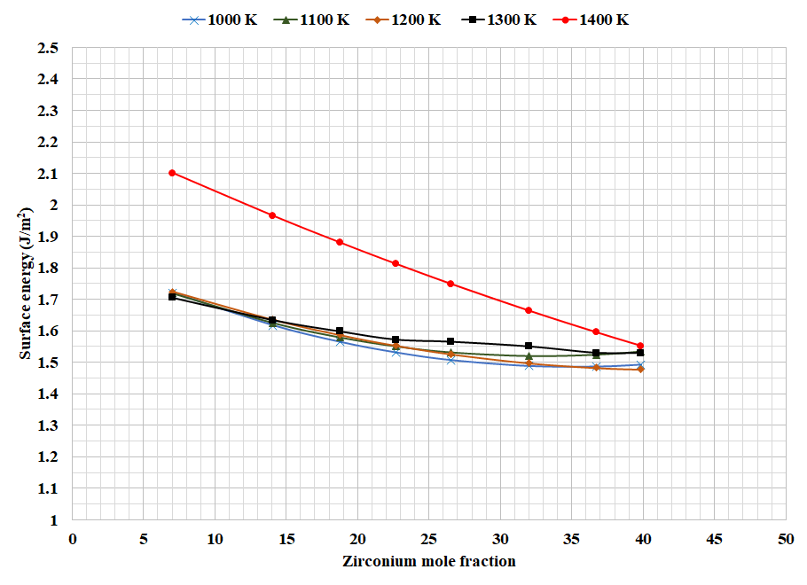

Fig. 9. Surface energy as a function of zirconium content between 1000 K and 1400 K for a surface with orientation (110).

Fig. 9 depicts the surface energy for a system with a (110) surface as a function of concentration at different temperatures. It can be noticed that, similar to the (100) system, the surface energy tends to decrease with increasing Zr content, but is almost constant above 25 at.% Zr. It can also be noticed that the temperature variation of the surface energy of this system is much lower than the (100) surface system. However, at 1400 K, similar to the (100) surface, it is clear that the system is less stable and is undergoing significant surface roughening, due to the anomalously high surface energy at 1400 K. This degree to which the surface energy at 1400 K is an outlier decreases with increasing Zr content, similar to the (100) surface, and due to the increase in the melting point with higher amounts of Zr in the alloy. This phenomenon of surface roughening near the melting point was verified via ….

Conclusions

# References

1. Tang, Y. S.; Coffield, Jr, R. D.; and Markley R. A. Thermal Analysis of Liquid-Metal Fast Breeder Reactors, 1st Edition; American Nuclear Society: USA, 1978.
2. Todreas, N. E. Thermal-Hydraulics Challenges in Fast Reactor Design. Nucl. Tech. 2009, 167:1, 127-144.
3. Yoo, C.-S.; Cyun, H.; Soderlind, P. Phase diagram of uranium at high pressures and temperatures, Phys. Rev. B57 (1998) 10359.
4. Habashi F. (2013) Uranium, Physical and Chemical Properties. In: Kretsinger R.H., Uversky V.N., Permyakov E.A. (eds) Encyclopedia of Metalloproteins. Springer, New York, NY. https://doi.org/10.1007/978-1-4614-1533-6_401
5. Soderlind, P. Theory of the crystal structures of cerium and the light actinides, Adv. In Phys. 47 (1998) 959.
6. Takahashi, Y.; Yamawaki, M.; Yamamoto, K. Thermophysical Properties of Uranium-Zirconium Alloys, J. Nucl. Mat. 1988, 154:1, 141-144.
7. Gaiduchenko, A.B. Thermophysical Properties of Irradiated Uranium-Zirconium Fuel, At. Energy. 2008, 104, 5-10.
8. Huang, S-Q. and Ju,X-H. First-Principles Study of Properties of Alpha Uranium Crystal and Seven Alpha Uranium Surfaces. J. Chem. 2017.
9. Davis, J. R., Metal Handbook Desk Edition, 2nd Edition; ASM:1998.
10. Zegler, S.T. and Walter, C.M. Compatibility between metallic U-Pu-base fuels and potential cladding materials, Nucl. Met. 13 (1967) 335-344
11. Sangjoon A., Comprehensice investigation of the uranium-zirconium alloy system:Thermophysical properties, phase characterization and ion implantation effects, Ph.D. Thesis, P.22 Texas A&M University, (2013).
12. Galloway, J. Unal, C. Carlson, N. Porter, D. Hayes, S. Modeling Constituent Redistribution in U-Pu-Zr Metallic Fuel Using the Advanced Fuel Performance Code BISON, Nucl. Eng. Des. (2015), 286, 1-17.
13. Beeler, B. Anderson, D. Jiang, C. Zhang, Y. Ab Initio Molecular Dynamics Investigation of Point Defects in γ-U, J. Nucl. Mat. 545 (2021) 152714.
14. Basak, C. An Evaluation of the Properties of AS-Cast U-rich U-Zr Alloys. J. Alloys and Compounds( 2009) 480, 857-962
15. Touloukian. Y. S. Kirby, R. K. Taylo, R. E. Desai, P. D. Thermophysical Properties of Matter vol. 12, Thermal Expansion: Metallic elements and Alloys, IFI Plenum, New York, (1975).
16. Lawson, A.C.; Olsen, C.E.; Richardson Jr., J.W.; Mueller, M.H.; Lander, G.H.; Structure of b-uranium, Acta Crystallographica, B44 (1988).
17. Heiming, A. Petry. W. Cockcroft, Trampenau, J. The Temperature Dependence of the Lattice Parameters of Pure BCC Zr and BCC Zr-2 at.% Co. J. Phys. Condens. Matter. 1992. 4, 727-733.
18. Petukhov, V., Thermal expansion of zirconium in the solid phase, High Temperatures-High Pressures 35/26 (2003/2004) 15-23.
19. Paradis, P.F.; Rhim, W.K.; Thermophysical properties of zirconium at high temperature, Journal of Materials Research, 14 (1999) 3713-3719.
20. Konings, R.J.M.; Beneš, O. The Thermodynamic Properties of the *f*-Elements and Their Compounds. I. The Lanthanide and Actinide Metals, Journal of Physical and Chemical Reference Data, 39 (2010) 043102.
21. Janney, D. E. Metallic Fuels Handbook, Part 1. Idaho National Laboratory, Idaho Falls, ID. 2017.

References from the course report that I might integrate some of them to the paper’s references.

[3] Galloway, J. Unal, C. Carlson, N. Porter, D. Hayes, S. Modeling Constituent Redistribution in U-Pu-Zr Metallic Fuel Using the Advanced Fuel Performance Code BISON, Nucl. Eng. Des. 2015, 286, 1-17.

[4] Beeler, B. Anderson, D. Jiang, C. Zhang, Y. Ab Initio Molecular Dynamics Investigation of Point Defects in γ-U, J. Nucl. Mat. Submitted June (2020).

[5] Takahashi, Y. Yamawaki, M. Yamamoto, K. Thermophysical Properties of Uranium-Zirconium Alloys, J. Nucl. Mat. 1988, 154:1, 141-144.

[6] Gaiduchenko, A.B. Thermophysical Properties of Irradiated Uranium-Zirconium Fuel, At. Energy. 2008, 104, 5-10.

[7] Huang, S-Q. and Ju,X-H. First-Principles Study of Properties of Alpha Uranium Crystal and Seven Alpha Uranium Surfaces. J. Chem. 2017.

[8] Manga, V. and Poirier, D. Ab Initio Molcular Dynamics Simulation of Self-Diffusion in Al-Si Binary Melts, Modelling Simul. Mater. Sci. Eng. 2018, 26.

[9] Hellman, O. Abrikosov, I. Simak, S. Lattice Dynamics of Anharmonic Solids from First Principles. Phys. Rev. 2011. Rev. B 84.

[10] Soderling, P. Grabowski, B. Yang, L. Landa A., Björkman T., Souvatzis P., Eriksson O. High-Temperature Phonon Stabilization of γ-Uranium from Relativistic First-Principles Theory. Phys. Rev. 2012. B 85.

[11] Kresse, G. and Hafner, J. Ab Initio Mocula Dynamics for Liquid Metals, Phys. Rev. 1993. B 47, 558.

[12] Kresse, G. and Furthmuller J. Efficiency of Ab-Initio Total Enery Calculations for Metals and Semiconductors Using a Plane-Wave Basis Set. Comput. Mat. Sci. 1996.

[13] Blochl, P. Projector Augmented-Wave Method. Phys. Rev. 1994. B 50

[14] Perdew, J. [Burke](https://pubmed.ncbi.nlm.nih.gov/?term=Burke+K&cauthor_id=10062328) K, [Ernzerhof](https://pubmed.ncbi.nlm.nih.gov/?term=Ernzerhof+M&cauthor_id=10062328), M. Generalized Gadient Approximation Made Simple. Phys. Rev. Lett. 1997. 78.

[15] MonKhorst, H. and Pack, J. Special Points for Brillouin-Zone Integration. Phys. Rev. 1976. B 13.

Heiming, A. Petry. W. Cockcroft, Trampenau, J. The Temperature Dependence of the Lattice Parameters of Pure BCC Zr and BCC Zr-2 at.% Co. J. Phys. Condens. Matter. 1992. 4, 727-733.

[16] Heiming, A. Petry. W. Cockcroft, Trampenau, J. The Temperature Dependence of the Lattice Parameters of Pure BCC Zr and BCC Zr-2 at.% Co. J. Phys. Condens. Matter. 1992. 4, 727-733.

[17] Basak, C. An Evaluation of the Properties of AS-Cast U-rich U-Zr Alloys. J. Alloys and Compounds 2009. 480, 857-962

[18] Touloukian. Y. S. Kirby, R. K. Taylo, R. E. Desai, P. D. Thermophysical Properties of Matter vol. 12, Thermal Expansion: Metallic elements and Alloys, IFI Plenum, New York, 1975.

[19] Saller, H. A. Dickerson, R.F. Murr, W.E. Uranium Alloys for High-Temperature Application. Battelle Memorial Institute, Columbus, OH, 1956.

[20] Moore, A.P. Beeler, B. Deo, C. Baskes, M.I. Okuniewski M.A. Atomistic Modeling of High Temperature Uranium Zirconium Alloy Structure and Thermodynamics. J. Nucl. Mat. 2015. 467, 802-819.

[21] Janney, D. E. Metallic Fuels Handbook, Part 1. Idaho National Laboratory, Idaho Falls, ID. 2017.